Technological Educational Institute of Central Macedonia
DEPARTMENT OF CIVIL ENGINEERING AND SURVEYING ENGINEERING AND GEOINFORMATICS

SPECIALIZATION COURSE IN SURVEYING ENGINEERING AND GEOINFORMATICS

AN OVERVIEW

The Specialization Course in Surveying Engineering and Geoinformatics (formerly Department of Geoinformatics and Surveying Engineering) of the Technological Educational Institute of Central Macedonia has been running since 2000 a four year undergraduate course that provides in breadth and depth education across the fields of Geoinformatics and Surveying. The undergraduate specialization program is leading to the degree of Bachelor of Science (BSc) and includes eight semesters (one of them is a semester of practical placement). The number of courses to pass in order to obtain the undergraduate degree is 40 (including the final thesis) leading to an overall work load of 350 units. There are in total 210 credits (ECTS) of general and specialized content: 30 credits in each semester, 10 credits for the practical training and 20 credits for the final thesis (a supervised student work which is presented and evaluated in public by a three member committee). Lectures are taught in amphitheatres or special classrooms fully equipped with visual aids. A large number of courses contain exercise and laboratory sessions. These modules are taught by providing an overview of the associated theory followed by the respective exercises in the laboratory or in the field.
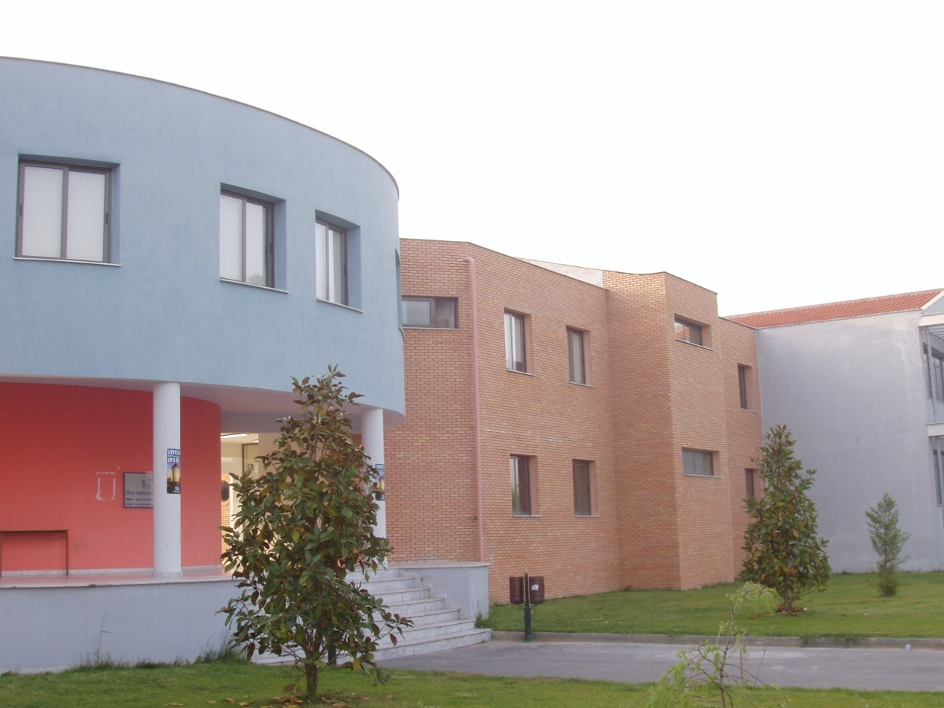
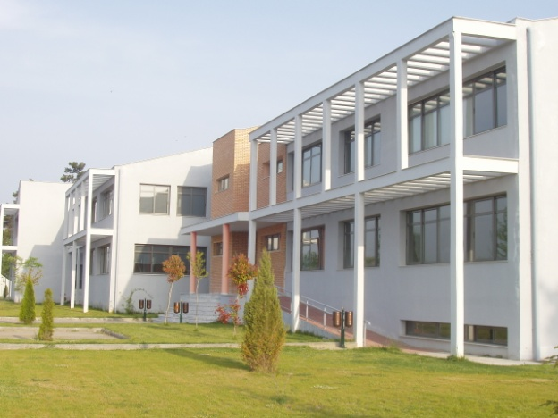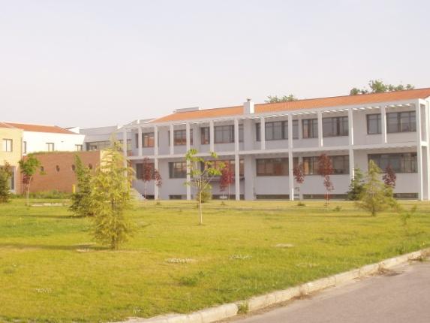
The performance of the students is assessed in a number of ways including both mid-term and final exams as well as coursework that students need to turn in at certain points in time during the semester. The final mark is determined as a weighted sum of the sub-marks achieved by the students at various performance assessment exercises employed by the module instructors. The educational staff makes extensive use of a web-based e-learning system for publishing syllabus, class-notes and announcements, while students seem to adopt in their whole this type of collaboration. 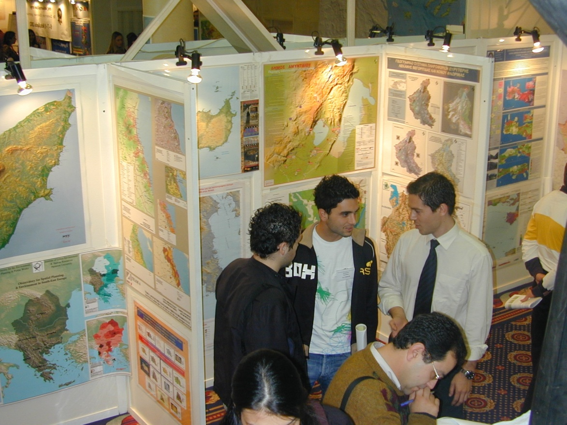

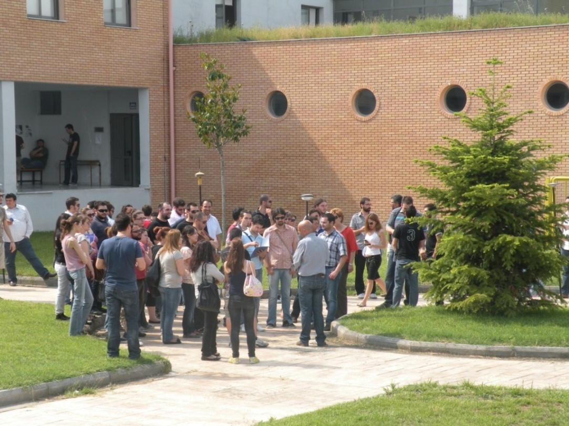

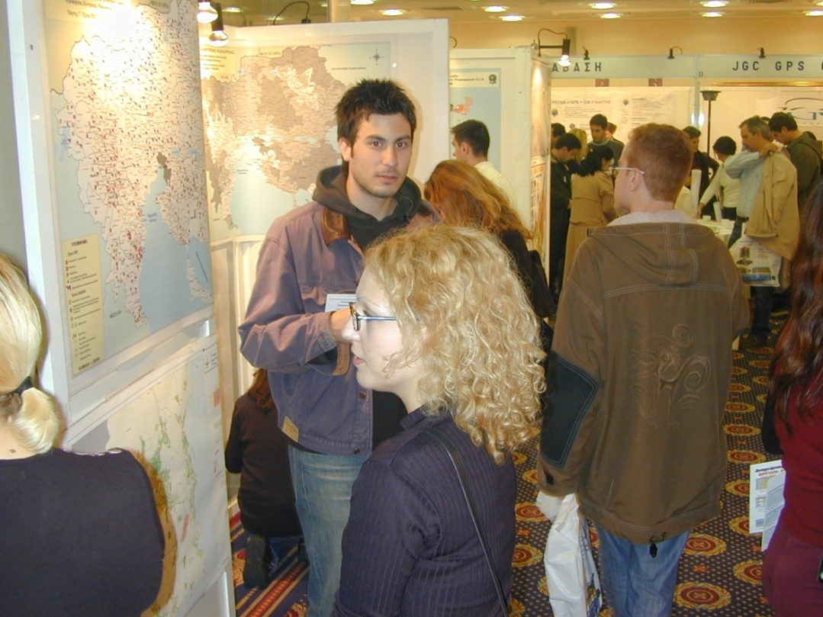
Currently, the department has eight full time faculty members (one professor, two associate professors, and five lecturers) and six (6) part time teaching and research associates, most of them holding a PhD degree. Although the nominal student to faculty permanent staff ratio is high, it should be noted that the current infrastructure, both in terms of physical space and equipment, is adequate enough and fulfills the requirements related to the total active mass of students.
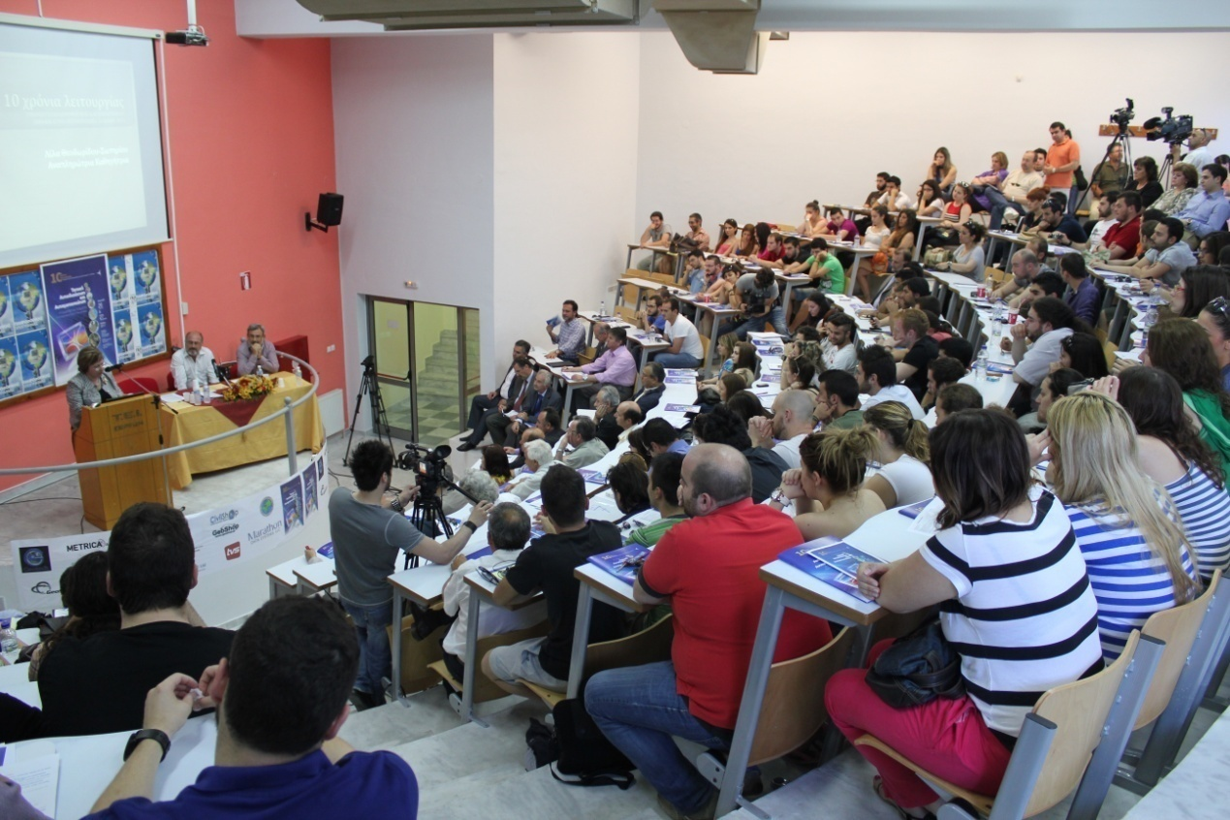

The department is a member of AGILE (Association of GI Laboratories in Europe) and EARSel (European Association of Remote Sensing Laboratories). The typical academic undergraduate program of the Department constitutes of the following courses.

Note: Lec: Lectures , Tut: Tutorials, Lab: Laboratories, HpW: Hours per Week ECTS: European Credit Transfer System Unit

1st Semester (Fall)
Code | Course |  |  |  | Lec | Tut | Lab | HpW | ECTS
101 | Mathematics | C |  |  | 4 | - | - | 4 | 7
102 | Applied Informatics (I) | C |  |  | 2 | 1 | 3 | 6 | 6
103 | Statistics and Elements of Probability Theory | C |  |  | 2 | - | - | 2 | 4
104 | Computer-Aided Design | C |  |  | 1 | 1 | 3 | 5 | 4
105 | Surveying (I) | C |  |  | 2 | - | 3 | 5 | 5
106 | Writing Technical Texts | C |  |  | 2 | - | - | 2 | 4
 | Total |  |  |  | 13 | 2 | 9 | 24 | 30
2nd Semester (Spring)

Code | Course |  |  |  | Lec | Tut | Lab | HpW | ECTS
201 | Surveying II | C |  |  | 2 | - | 3 | 5 | 5
202 | Applied Informatics (II) | C |  |  | 2 | 1 | 3 | 6 | 6
203 | General and Applied Geology | C |  |  | 2 | 1 | 1 | 4 | 5
204 | Programming in Design Software | C |  |  | 2 | - | 3 | 5 | 5
205 | Course in English Language | C |  |  | 2 | - | - | 2 | 4
206 | Introduction to Cartography | C |  |  | 2 | - | 2 | 4 | 5
 | Total |  |  |  | 12 | 2 | 12 | 26 | 30

3rd Semester (Fall)

Code | Course |  | Lec | Tut | Lab | HpW | ECTS.
301 | Photogrammetry I | C | 2 | - | 3 | 5 | 6
302 | Regional Planning and Development | C | 2 | 1 | 2 | 5 | 5
303 | Databases | C | 2 | 1 | 2 | 5 | 5
304 | Human Geography and Spatial Economics | C | 2 | 1 | - | 3 | 4
305 | Road Engineering | C | 2 | - | 2 | 4 | 5
306 | Algorithms in Geomatics | C | 2 | - | 2 | 4 | 5
 | Total |  | 12 | 3 | 11 | 26 | 30

4th Semester (Spring)

Code | Course |  | Lec | Tut | Lab | HpW | ECTS.
401 | GIS I | C | 2 | 1 | 3 | 6 | 6
402 | Photogrammetry II | C | 2 | - | 2 | 4 | 5
403 | Geomatics and Transportation | C | 2 | 1 | 1 | 4 | 5
404 | Quantitative methods in Geographical Analysis | C | 2 | 1 | - | 3 | 4
405 | Cadastral Surveying | C | 2 | 1 | 1 | 4 | 5
406 | Urban Space Transformations | C | 2 | 1 | 2 | 5 | 5
 | Total |  | 12 | 5 | 9 | 26 | 30

5th Semester (Fall)
Code | Course |  |  | Lec | Tut | Lab | HpW | ECTS
501 | Satellite Geodesy (GPS) |  | C | 3 | 1 | 3 | 7 | 8
502 | GIS Applications (GIS II) |  | C | 2 | 1 | 3 | 6 | 6
503 | Remote Sensing |  | C | 3 | 1 | 2 | 6 | 7
504 | Thematic and Digital Cartography |  | C | 2 | 1 | 1 | 4 | 5
 | Electives
505 | Environmental Legislation |  | CC | 2 | 1 | - | 3 | 4
505 | Decision Support Systems and GIS |  | CC | 2 | 1 | - | 3 | 4
 | Total |  |  | 12 | 5 | 9 | 26 | 30
 | 6th Semester (Spring)
Code | Course |  |  | Lec | Tut | Lab | HpW | ESTS
601 | Applications in Regional and Urban Planning (GIS III) |  | C | 2 | 2 | 3 | 6 | 7
602 | Topographic and Geodetic Networks |  | C | 2 | 1 | 2 | 5 | 5
603 | Remote Sensing Applications and Mapping |  | C | 3 | 1 | 1 | 5 | 7
604 | Acts of Settlement and Actuarial |  | C | 2 | 1 | 3 | 6 | 6
 | Electives
605 | Urban Planning |  | CC | 2 | 1 | 2 | 5 | 5
606 | Environmental Planning and Spatial Analysis |  | CC | 2 | 1 | 2 | 5 | 5
 | Total |  |  | 11 | 6 | 11 | 28 | 30

 | 7th Semester (Fall)
Code | Course |  | Lec | Tut | Lab | HpW | ECTS
701 | Cartographic Visualizations | C | 3 | 1 | 1 | 5 | 7
702 | Automation Systems Applications and Local Authorities | C | 2 | - | 2 | 4 | 5
703 | Ecology and Sustainable Development | C | 3 | 1 | 1 | 5 | 6
704 | Applied Urban Planning | C | 2 | 1 | 3 | 6 | 6
 | Electives
701 | Geomatics Software Design and Development | CC | 2 | 1 | 3 | 6 | 6
706 | Cultural Documentation Systems | CC | 2 | 1 | 3 | 6 | 6
 | Total |  | 12 | 4 | 10 | 26 | 30
 | Total |  | 84 | 27 | 71 | 182 | 210
 | Total Lec +Tut |  |  | 111
 | (Lec+Tut)/ Lab= |  |  | 1,56
 | Lab+0.50*Ε = |  | 106.5

8th Semester
Code | Course |  |  | Lec | Tut | Lab | HpW | ECTS
- | Diploma Thesis |  |  |  |  |  |  | 20
- | Practical Placement |  |  |  |  |  |  | 10
 | Total |  |  |  |  |  |  | 30

We are looking forward to welcoming you to our Department in our beautiful campus located at the south edge of the charming city of Serres.

Lila Theodoridou-Sotiriou
Professor
Head of the Department

